ASSIGNMENT-20.1
NAME:-A.BHAVITHA
BATCH:-13
ENROLLMENT NUMBER:-2603A52L02
Task 1 – Input Validation Check
Task:
Analyze an AI-generated Python login script for input validation vulnerabilities.
Instructions:
- Prompt AI to generate a simple username-password login program.
- Review whether input sanitization and validation are implemented.
- Suggest secure improvements (e.g., using re for input validation).
PROMPT:-
Generate a Python username-password login program. Check whether the username and password are valid. Use regular expressions to validate the username and ensure the password has at least 8 characters. Display appropriate error messages for invalid inputs.
INPUT:-
import re
username = input("Enter username: ")
password = input("Enter password: ")
if not re.fullmatch(r"[A-Za-z0-9_]{4,15}", username):
print("Invalid username")
elif len(password) < 8:
print("Password must contain at least 8 characters")
else:
print("Input validation successful")
# Demo credentials only; do not use hardcoded
# passwords in a real application.
if username == "student" and password == "student123":
print("Login successful")
else:
print("Invalid username or password")
OUTPUT:- 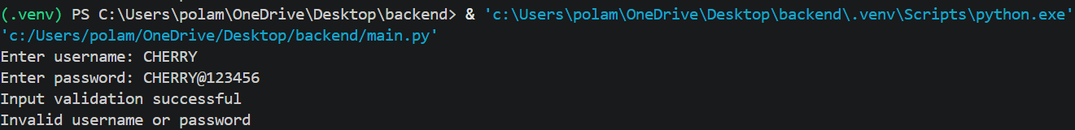
Task 2 – SQL Injection Prevention
Task:
Test an AI-generated script that performs SQL queries on a database.
Instructions:
- Ask AI to generate a Python script using SQLite/MySQL to fetch user details.
- Identify if the code is vulnerable to SQL injection (e.g., using string concatenation in queries).
- Refactor using parameterized queries (prepared statements).
PROMPT:- Generate a Python program using SQLite to fetch user details from a database. Identify SQL injection vulnerabilities and prevent them by using parameterized queries instead of string concatenation.
INPUT:-
import sqlite3
conn = sqlite3.connect("users.db")
cursor = conn.cursor()
cursor.execute("""
CREATE TABLE IF NOT EXISTS users (
id INTEGER PRIMARY KEY,
username TEXT,
email TEXT
)
""")
cursor.execute("DELETE FROM users")
cursor.execute(
"INSERT INTO users (username, email) VALUES (?, ?)",
("john", "john@gmail.com")
)
conn.commit()
username = input("Enter username: ")
# Parameterized query prevents SQL injection
cursor.execute(
"SELECT * FROM users WHERE username = ?",
(username,)
)
result = cursor.fetchone()
if result:
print("User Details:", result)
else:
print("User not found")
conn.close()
OUTPUT:-
Task 3 – Cross-Site Scripting (XSS) Check
Task:
Evaluate an AI-generated HTML form with JavaScript for XSS vulnerabilities.
Instructions:
- Ask AI to generate a feedback form with JavaScript-based output.
- Test whether untrusted inputs are directly rendered withoutescaping.
- Implement secure measures (e.g., escaping HTML entities, using CSP).
PROMPT:-
Generate an HTML feedback form using JavaScript. Check for Cross-Site Scripting (XSS) vulnerabilities. Prevent XSS attacks by displaying user input using textContent instead of innerHTML. Include a Content Security Policy to improve security.
INPUT:-
<!DOCTYPE html>
<html>
<head>
<title>Feedback Form</title>
<meta http-equiv="Content-Security-Policy"
content="default-src 'self'; script-src 'self';
object-src 'none'; base-uri 'self';">
</head>
<body>
<h2>Feedback Form</h2>
<input type="text" id="feedback"
placeholder="Enter your feedback">
<button id="submitBtn">Submit</button>
<h3>Your Feedback:</h3>
<p id="result"></p>
<script src="feedback.js"></script>
</body>
</html>
OUTPUT:-
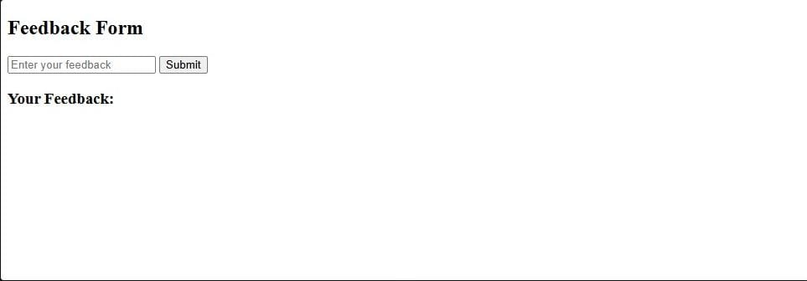

Task 4 – Real-Time Application: Security Audit of AI-Generated Code
Scenario:
Students pick an AI-generated project snippet (e.g., login form, API integration, or file upload).
Instructions:
- Perform a security audit to detect possible vulnerabilities.
- Prompt AI to suggest secure coding practices to fix issues.
- Compare insecure vs secure versions side by side.
PROMPT:-
Generate a Python file upload program. Identify security vulnerabilities such as unrestricted file types, large file uploads, and unsafe filenames. Provide a secure version using Flask, file type validation, file size limits, secure_filename(), and unique filenames.
INPUT:-
from flask import Flask, request
app = Flask(__name__)
@app.route("/upload", methods=["POST"])
def upload():
file = request.files["file"]
# Insecure: no file validation
# and original filename is used
file.save("uploads/" + file.filename)
return "File uploaded successfully"
app.run(debug=True)
OUTPUT:- 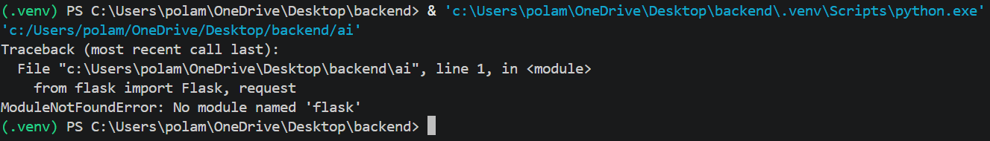
Task 5 – Insecure Data Serialization Check
Task:
Evaluate AI-generated code that uses pickle for saving user data.
Instructions:
- Ask AI to generate a script using pickle.load().
- Explain why untrusted pickle data is dangerous.
- Replace with safer formats like JSON.
PROMPT:-
Generate a Python program that saves and loads user data using pickle. Explain why loading untrusted pickle data is dangerous. Replace pickle with the safer JSON format for saving and reading user data.
INPUT:-
import pickle
user = {
"name": "John",
"age": 21
}
with open("user.pkl", "wb") as file:
pickle.dump(user, file)
with open("user.pkl", "rb") as file:
data = pickle.load(file)
print(data)
OUTPUT:-

